33. Scatter Plot with Empty Circles

import matplotlib.pyplot as plt
import numpy as np
x = np.random.rand(50)
y = np.random.rand(50)
plt.scatter(x, y, facecolors='none', edgecolors='blue')
plt.xlabel('X')
plt.ylabel('Y')
plt.title('Scatter Plot with Empty Circles')
plt.show()
OUTPUT:
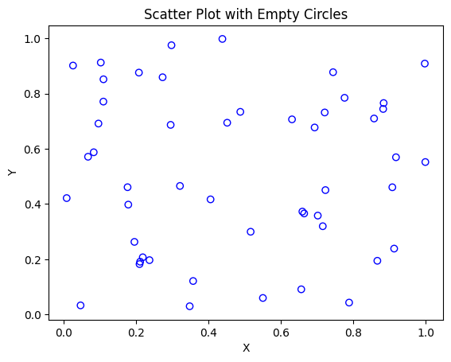
34. Scatter Plot with Balls of Different Sizes

import matplotlib.pyplot as plt
import numpy as np
x = np.random.rand(50)
y = np.random.rand(50)
sizes = np.random.randint(20, 500, 50)
plt.scatter(x, y, s=sizes, alpha=0.5)
plt.xlabel('X')
plt.ylabel('Y')
plt.title('Scatter Plot with Different Ball Sizes')
plt.show()
OUTPUT:
